# AMNA MANSOOR 22K-5159 BSE-3B LAB-2

*TASK 1:*

import java.util.Scanner;  
public class Task1 {  
 public static void main(String[] args) {  
  
 Scanner sc=new Scanner(System.*in*);  
 System.*out*.println("Enter number of elements in array: ");  
 int n= sc.nextInt();  
 int[] array=new int[n];  
  
 System.*out*.println("Enter elements of Array: ");  
 for (int i=0;i<n;i++){  
 System.*out*.printf("Element "+i+": ");  
 array[i]=sc.nextInt();  
 }  
 int even = 0, odd = 0;  
 for (int i = 0; i < n; i++) {  
 if (array[i] % 2 == 0) {  
 even++;  
 }  
 if (array[i] % 2 != 0) {  
 odd++;  
 }  
 }  
 System.*out*.println("Even elements:" + even);  
 System.*out*.println("Odd elements:" + odd);  
  
 int[] evenArr = new int[even];  
 int[] oddArr = new int[odd];  
  
 int j = 0, k = 0;  
 for (int i = 0; i < n; i++) {  
 if (array[i] % 2 == 0) {  
 evenArr[j++] = array[i];  
 }  
 if (array[i] % 2 != 0) {  
 oddArr[k++] = array[i];  
 }  
 }  
 System.*out*.println("\nOriginal Array: ");  
 for (int i = 0; i < n; i++) {  
 System.*out*.printf(array[i] + " ");  
 }  
 System.*out*.println("\n\nEven Array: ");  
 for (int i = 0; i < even; i++) {  
 System.*out*.printf(evenArr[i] + " ");  
 }  
 System.*out*.println("\n\nOdd Array: ");  
 for (int i = 0; i < odd; i++) {  
 System.*out*.printf(oddArr[i] + " ");  
 }  
 }  
}

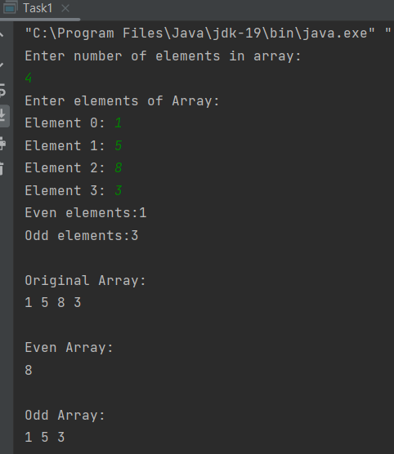

*TASK 2:*

import java.util.ArrayList;  
import java.util.Scanner;  
  
public class Task2 {  
 public static void main(String[] args) {  
 Scanner sc=new Scanner(System.*in*);  
  
 System.*out*.println("Enter number of elements in the Arrays: ");  
 int n= sc.nextInt();  
 int[] arr1=new int[n];  
 int[] arr2=new int[n];  
 System.*out*.println("Enter elements of Array 1: ");  
 for (int i=0;i<n;i++){  
 System.*out*.printf("Element "+i+": ");  
 arr1[i]=sc.nextInt();  
 }  
 System.*out*.println("Enter elements of Array 2: ");  
 for (int i=0;i<n;i++){  
 System.*out*.printf("Element "+i+": ");  
 arr2[i]=sc.nextInt();  
 }  
 ArrayList<Integer> common=new ArrayList<>();  
 for (int i=0;i<n;i++){  
 for (int j=0;j<n;j++){  
 if (arr1[i]==arr2[j]){  
 common.add(arr1[i]);  
 break;  
 }  
 }  
 }  
 System.*out*.println("Common Elements: ");  
  
 for (int i=0;i<common.size();i++){  
 System.*out*.print(common.get(i)+" ");  
 }  
 }  
}

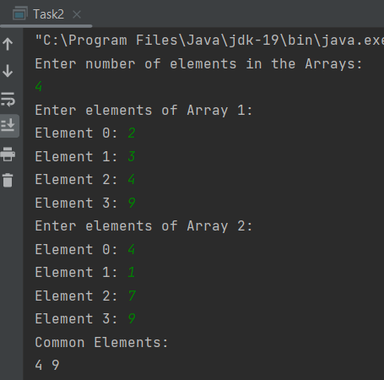

*TASK 3:*

import java.util.Scanner;  
  
public class Task3 {  
 public static void main(String[] args) {  
 Scanner sc = new Scanner(System.*in*);  
 float GPA[][] = new float[5][];  
 System.*out*.println("Enter GPA of the subjects");  
  
 GPA[0] = new float[5];  
 GPA[1] = new float[5];  
 GPA[2] = new float[5];  
 GPA[3] = new float[2];  
 GPA[4] = new float[4];  
 System.*out*.println("Enter GPA for Student 1: ");  
 for (int i = 0; i < 5; i++) {  
 GPA[0][i] = sc.nextFloat();  
 }  
 System.*out*.println("Enter GPA for Student 2: ");  
 for (int i = 0; i < 5; i++) {  
 GPA[1][i] = sc.nextFloat();  
 }  
 System.*out*.println("Enter GPA for Student 3: ");  
 for (int i = 0; i < 5; i++) {  
 GPA[2][i] = sc.nextFloat();  
 }  
 System.*out*.println("Enter GPA for Student 4: ");  
 for (int i = 0; i < 2; i++) {  
 GPA[3][i] = sc.nextFloat();  
 }  
 System.*out*.println("Enter GPA for Student 5: ");  
 for (int i = 0; i < 4; i++) {  
 GPA[4][i] = sc.nextFloat();  
 }  
 for (int i = 0; i < 5; i++) {  
 float gpa = 0;  
 int totalSubjects = GPA[i].length;  
 for (int j = 0; j < totalSubjects; j++) {  
 gpa += GPA[i][j];  
 }  
 float studentGPA = gpa / totalSubjects;  
 System.*out*.println("GPA for Student- "+(i+1)+" :"+studentGPA);  
 }  
 }  
}

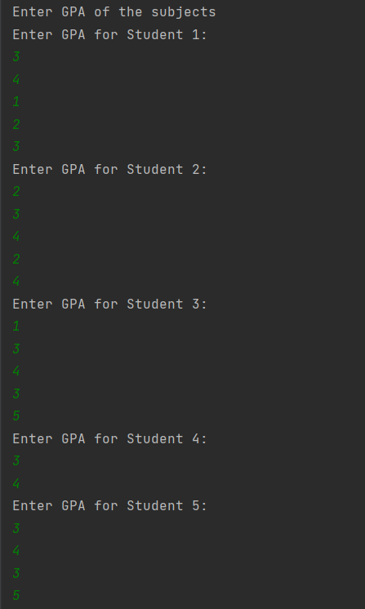

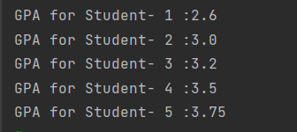

*TASK 4:*

import java.util.Scanner;  
  
public class Task4 {  
 public static void main(String[] args) {  
 Scanner sc=new Scanner(System.*in*);  
  
 System.*out*.println("Enter number of elements: ");  
 int n= sc.nextInt();  
 System.*out*.println("Enter Array of Unsorted Elements: ");  
 int[] array=new int[n];  
 for (int i=0;i<n;i++){  
 array[i]=sc.nextInt();  
 }  
  
 boolean even=false;  
 int temp;  
 for (int i=0;i<n-1;i++){  
 for (int j=0; j<n-1-i;j++){  
 if(array[j] > array[j + 1]){  
 temp=array[j];  
 array[j]=array[j+1];  
 array[j+1]=temp;  
 }  
 }  
 }  
 if (array[0] % 2 == 0) {  
 for (int i = 0; i < n; i++) {  
 for (int j = n- 2; j > 0; j--) {  
 if (array[j] % 2 != 0 && array[j+1] % 2 == 0) {  
 temp = array[j];  
 array[j] = array[j + 1];  
 array[j + 1] = temp;  
 }  
 }  
 }  
  
 }  
 if (array[0] % 2 == 1) {  
 for (int i = 0; i < n; i++) {  
 for (int j = n- 2; j > 0; j--) {  
 if (array[j] % 2 != 1 && array[j+1] % 2 == 1) {  
 temp = array[j];  
 array[j] = array[j + 1];  
 array[j + 1] = temp;  
 }  
 }  
 }  
  
 }  
 System.*out*.println("Sorted Array: ");  
 for (int i=0;i<n;i++){  
 System.*out*.println(array[i]+" ");  
 }  
  
  
 }  
  
}

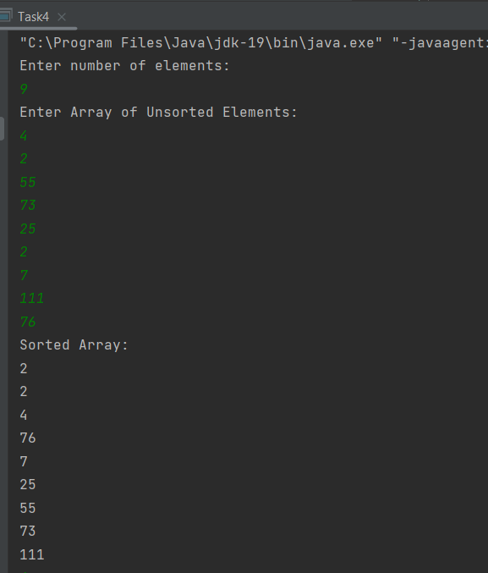

*TASK 5:*

import java.util.Scanner;  
  
public class Task5 {  
 public static void main(String[] args) {  
 Scanner sc=new Scanner(System.*in*);  
  
 System.*out*.println("Enter number of elements: ");  
 int n= sc.nextInt();  
 System.*out*.println("Enter Array of Unsorted Elements: ");  
 int[] array=new int[n];  
 for (int i=0;i<n;i++){  
 array[i]=sc.nextInt();  
 }  
  
 boolean even=false;  
 int temp;  
 for (int i=0;i<n-1;i++){  
 for (int j=0; j<n-1-i;j++){  
 if(array[j] < array[j + 1]){  
 temp=array[j];  
 array[j]=array[j+1];  
 array[j+1]=temp;  
 }  
 }  
 }  
 if (array[0] % 2 == 0) {  
 for (int i = 0; i < n; i++) {  
 for (int j = n- 2; j > 0; j--) {  
 if (array[j] % 2 != 0 && array[j+1] % 2 == 0) {  
 temp = array[j];  
 array[j] = array[j + 1];  
 array[j + 1] = temp;  
 }  
 }  
 }  
  
 }  
 if (array[0] % 2 == 1) {  
 for (int i = 0; i < n; i++) {  
 for (int j = n- 2; j > 0; j--) {  
 if (array[j] % 2 != 1 && array[j+1] % 2 == 1) {  
 temp = array[j];  
 array[j] = array[j + 1];  
 array[j + 1] = temp;  
 }  
 }  
 }  
  
 }  
 System.*out*.println("Sorted Array: ");  
 for (int i=0;i<n;i++){  
 System.*out*.println(array[i]+" ");  
 }  
  
  
 }  
  
}

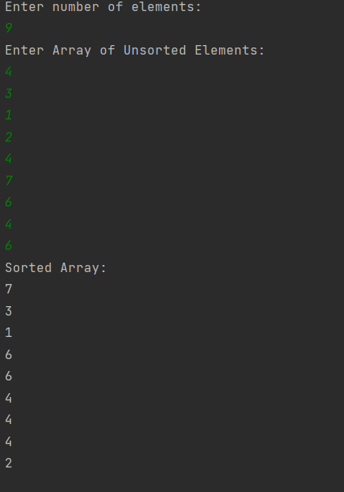

*Task 6:*

import java.util.Scanner;  
  
public class Task6 {  
 public static void main(String[] args) {  
 Scanner sc=new Scanner(System.*in*);  
 System.*out*.println("Enter number of elements: ");  
 int n= sc.nextInt();  
 System.*out*.println("Enter Array of Unsorted Elements: ");  
 int[] array=new int[n];  
 for (int i=0;i<n;i++){  
 array[i]=sc.nextInt();  
 }  
  
 boolean swapped;  
 int temp;  
  
 for (int i=0;i<n-1;i++){  
 swapped=false;  
 for (int j=0; j<n-i-1;j++){  
 if(array[j]>array[j+1]){  
 temp=array[j];  
 array[j]=array[j+1];  
 array[j+1]=temp;  
  
 swapped=true;  
 }  
 }  
 if (swapped==false){  
 break;  
 }  
 }  
 System.*out*.print("\nSorted Array: ");  
 for (int i=0;i<n;i++){  
 System.*out*.print(array[i]+" ");  
 }  
  
}  
}

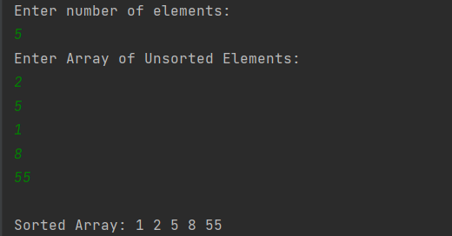

*TASK 7:*

import java.util.Scanner;  
  
public class Task7 {  
 public static void main(String[] args) {  
 Scanner sc=new Scanner(System.*in*);  
 System.*out*.println("Enter the number of Strings in the Array: ");  
 int n= sc.nextInt();  
  
 String[] arr=new String[n];  
 System.*out*.println("Enter the Elements of String Array: ");  
 for (int i=0;i<n;i++){  
 arr[i]= sc.next();  
 }  
 *Lexicographic*(arr);  
 System.*out*.print("Sorted Array: ");  
 for (int i=0;i<n; i++){  
 System.*out*.print(arr[i]+", ");  
 }  
 }  
 public static void Lexicographic(String[] arr){  
 int n= arr.length;  
 String temp;  
 for(int i = 0; i < n; i++ ) {  
 for(int j = 0; j < n-1-i; j++) {  
 if (arr[j].compareTo(arr[j+1])>0){  
 temp = arr[j];  
 arr[j] = arr[j + 1];  
 arr[j + 1] = temp;  
 }  
 }  
 }  
 }  
}

